Computing Exp 3

Task: Create a latex like code editor that handles basic arithmetic operations such as fraction, power, subscript, integration, differentiation, summation, etc.

Run code: gcc comp3.c -o comp3 `sdl2-config --cflags --libs` -lSDL2_ttf

Fraction:
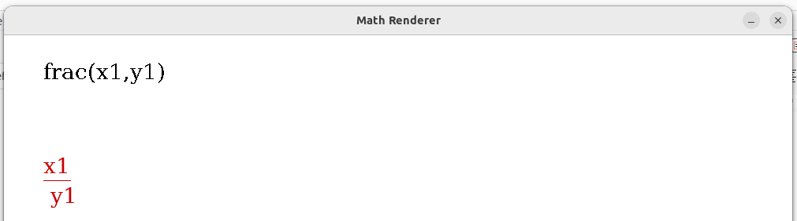

Power:
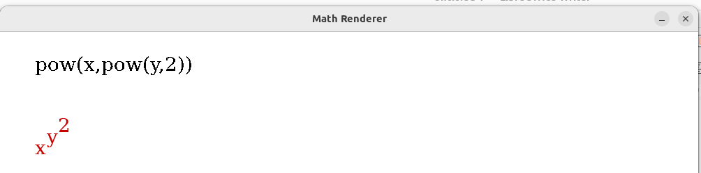

Subscript:
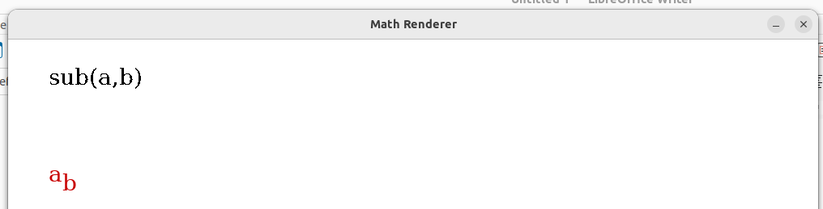

Integration:
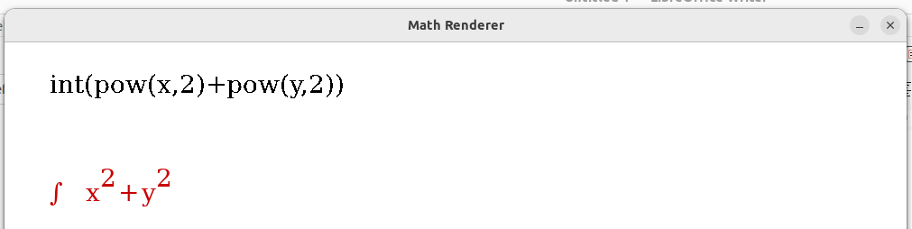

Differentiation:
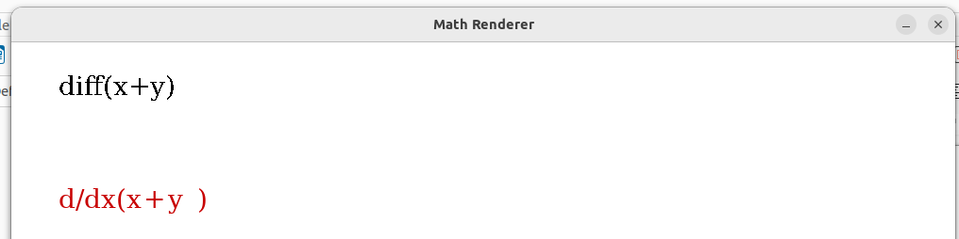

Summation:
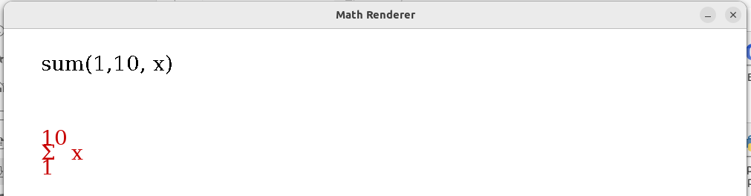

Basic operation:
